DEEPIKA.R
192412286
EXPERIMENT 10
Sensitivity Analysis of a Quarter-Wave Transformer
Aim
To investigate the sensitivity of a quarter-wave transformer to length errors by designing a transformer for matching 50 Ω to 100 Ω at 2.4 GHz, varying its length by −20%, −10%, 0%, +10%, and +20%, and plotting the corresponding input SWR.
Software Required
• MATLAB (or Scilab)
• MATLAB/Scilab plotting environment
Given Parameters
Source impedance, Z₀ = 50 Ω
Load impedance, ZL = 100 Ω
Frequency, f = 2.4 GHz
Speed of light, c = 3 × 10⁸ m/s
Design Calculations
Quarter-wave transformer impedance:
Zt = √(Z₀ ZL)
Zt = √(50 × 100) = 70.71 Ω
Wavelength:
λ = c/f = (3 × 10⁸)/(2.4 × 10⁹) = 0.125 m = 125 mm
Ideal quarter-wave transformer length:
l₀ = λ/4 = 125/4 = 31.25 mm
MATLAB Code
clc;
clear;
close all;
% Given parameters
Z0 = 50; % Source impedance in ohms
ZL = 100; % Load impedance in ohms
f = 2.4e9; % Frequency in Hz
c = 3e8; % Speed of light
% Quarter-wave transformer impedance
Zt = sqrt(Z0*ZL);
% Wavelength and ideal length
lambda = c/f;
l0 = lambda/4;
% Length errors
error = [-20 -10 0 10 20];
% Actual transformer lengths
lengths = l0*(1 + error/100);
% Phase constant
beta = 2*pi/lambda;
% Input impedance
Zin = Zt .* (ZL + 1j*Zt.*tan(beta.*lengths)) ./ ...
(Zt + 1j*ZL.*tan(beta.*lengths));
% Reflection coefficient
Gamma = (Zin-Z0)./(Zin+Z0);
% Input SWR
SWR = (1+abs(Gamma))./(1-abs(Gamma));
% Display results
fprintf('Transformer impedance = %.2f ohm\n', Zt);
fprintf('Wavelength = %.2f mm\n', lambda*1000);
fprintf('Ideal length = %.2f mm\n\n', l0*1000);
fprintf('Error(%%) Length(mm) Input SWR\n');
for k = 1:length(error)
fprintf('%+5.0f %8.2f %.3f\n', ...
error(k), lengths(k)*1000, SWR(k));
end
% Plot Input SWR
figure;
plot(error, SWR, '-o', 'LineWidth', 2);
grid on;
xlabel('Transformer Length Error (%)');
ylabel('Input SWR');
title('Sensitivity of Quarter-Wave Transformer to Length Errors');
xticks(error);
Result
Length Error | Transformer Length (mm) | Input SWR
−20% | 25.00 | 1.244
−10% | 28.12 | 1.117
0% | 31.25 | 1.000
+10% | 34.38 | 1.117
+20% | 37.50 | 1.244
Result Graph
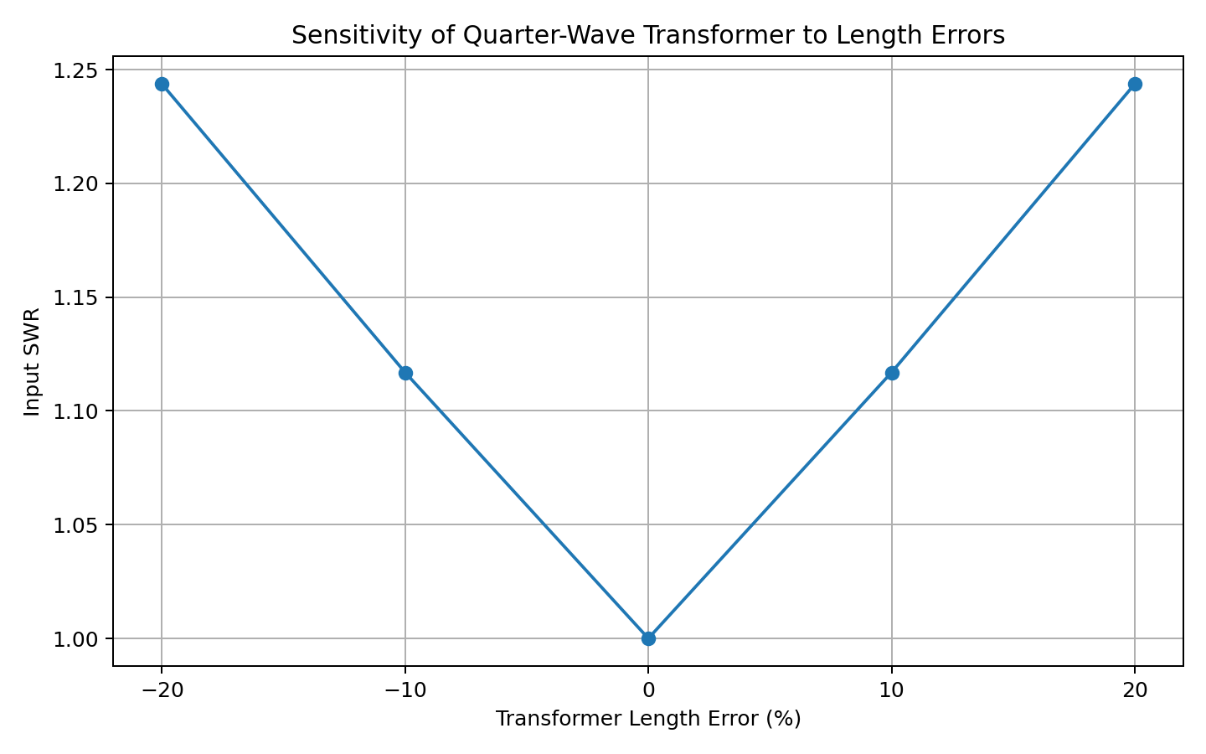
Observation
The ideal quarter-wave length is 31.25 mm, where the input SWR is 1.0, indicating perfect matching. As the transformer length deviates from the ideal value, the SWR increases. For ±20% length error, the input SWR becomes approximately 1.244.
Conclusion
The quarter-wave transformer is sensitive to physical length errors. The best impedance matching occurs at the ideal length of 31.25 mm. Accurate fabrication of the transformer length is therefore important for achieving minimum reflection and maximum power transfer.

